
Ultimate Gaging Systems
555 Plymouth Ave. NE
Grand Rapids, MI 49505
616-264-6962

Part name: BRKT SPARE TIRE HOIS
Part #: anu21851.geo_fin001.001002
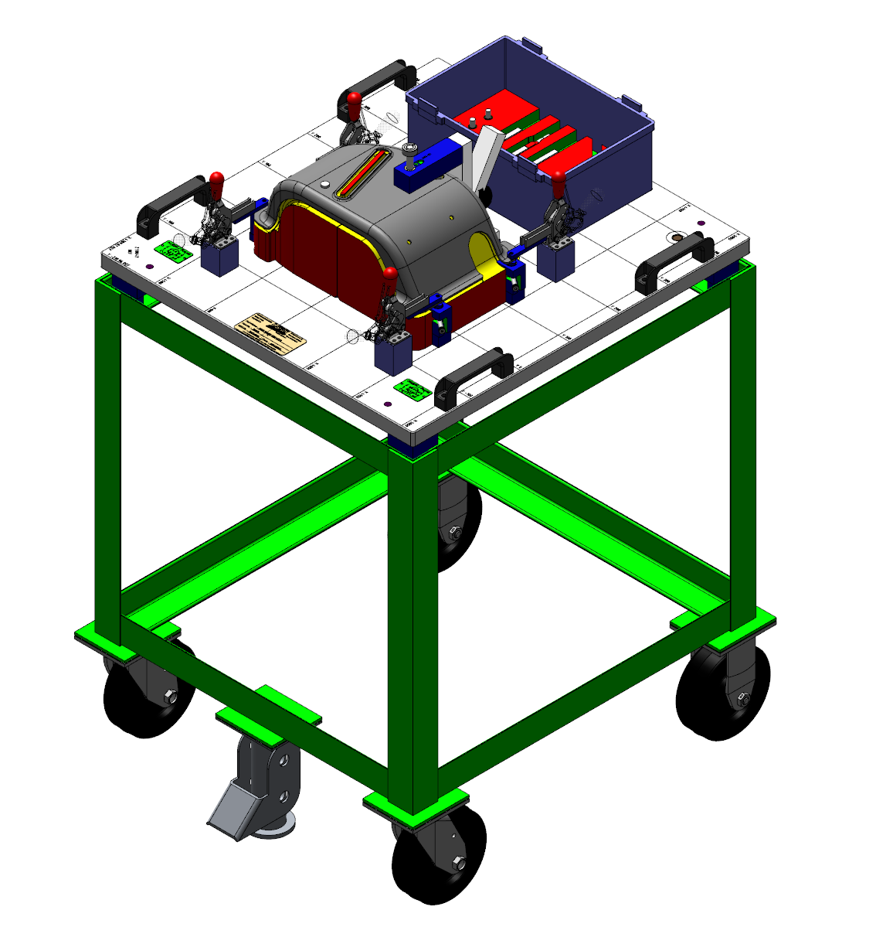

UGS Job: 2103-000
Customer: ETS

Contact: Brian Bkius

